 | Job Description
Date: |  | March 2021
Job Title: |  | Management Accountant
Post Number:

Division/Department/Section: |  | Alliance Finance and Business Support Services Department. Location to be determined however will be required to travel and work from both HQs as required.
Line Manager  (Name/Title & Post Number) |  | Head of Business Accounting
- PURPOSE

(Briefly describe in only one or two sentences the essential purpose of the job.)

To manage the preparation, maintenance and control of the Dorset and Devon & Cornwall Police revenue and capital budgets. To oversee all other accountancy functions within the force, including costing models and business support and to comply with accounting standards and best practice. To oversee and manage the system of devolved financial management. To provide financial expertise on project boards and other meetings.

To provide an advisory and consultative function, and to ensure an effective technical and business information service to key internal and external stakeholders.
- POSITION IN THE ORGANISATION

- Show this post’s position in the structure in a diagram – please indicate in this diagram the job titles of the job above this role, those alongside and those directly below)

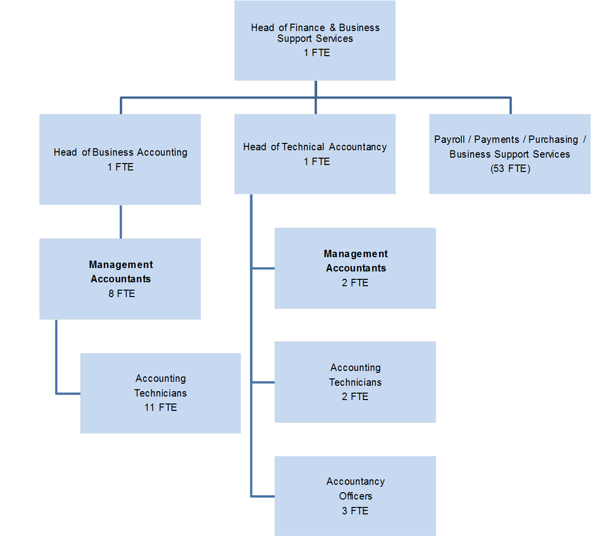
(b) Where relevant, list the people who work directly for this post and say briefly what they do. (Use one line to describe their role and responsibilities)

The Management Accountant posts have responsibility for Accounting Technician posts and Accountancy Officers. The Accounting Technician posts deliver direct financial and business support to senior managers, budget holders, acting as their single points of contact for all financial issues. They assist with technical accounting as necessary, including preparation of year end accounts, and capital accounting. The Accountancy Officers provide technical accounting support, including control account reconciliation, treasury management services, and data input / extraction.

- MAIN RESPONSIBILITIES

(List the main responsibilities this post is responsible for delivering results in – refer to guidance notes for completion of a JDQ)

What is the post responsible for?  (INPUT) | With what results?  (OUTPUT)
The following sets out the key responsibilities of the Management Accountant role. Each Management Accountant would be expected to be able to deliver any of these areas of responsibilities, although the responsibilities are spread across all Management Accountant posts. Each Management Accountant will support a defined area of activity, which would be subject to change, with the following schedule of responsibilities therefore indicative of the level / type of work carried out.

Provide accountancy support at a senior level to budget holders, and provide guidance to Accountancy Officers to ensure they provide appropriate accountancy support. | Accountancy Officers able to provide Direct Delivery of accountancy to Budget Holders, with appropriate advanced accountancy support available when necessary.
Lead the annualised / rolling budget and forecasting processes, preparation, review and consolidation for all areas of the business in order to produce the MTFS for each Force. | Budgets accurately prepared with additional three year forecasts completed for all Force budgets.
Oversee devolved budget monitoring carried out by Accounting Technicians, and to quality assure their service. | Provision of timely, accurate, monitoring information each month.
Monitor and report on police pay, police staff, and pensions budgets throughout year and future years through the budget monitoring and budget setting process. Forecast expenditure and assess impact of leavers and new recruits. Liaise with HR in respect of recruitment strategy and workforce planning. | Projected variances during each year are reported in order that remedial action can be taken. Affordable and achievable recruitment strategy can be set.
Prepare centrally held budgets not allocated to specific Divisions / Departments, and oversee work of Accounting Technicians in devolved budget setting. | Budget set correctly to minimise any under or over spending.
Lead on provision of technical accounting including creating and implementing Standard Operating Procedures, ensuring compliances with relevant legislation and regulation. | Force finances operating within relevant legislation.
Plan and coordinate the implementation of changes to accounting procedures including co-ordinating the work of team members, other colleagues and consultant as appropriate, and providing relevant training and support. | Enabling a dynamic, responsive and developing accountancy function that is fit for purpose, with appropriate levels of staff development.
Lead on the financial year-end close down, including producing guidelines, timetable and delivering year-end workshops. Provide technical accounting expertise during the financial year-end close down and the completion of the statutory annual report and accounts. Support the Accounting Technicians in preparation of year-end working papers, compilation of Creditors and Debtors inventories. | Ensure the Dorset Police accounts are produced by the specified deadlines. Ensure budget managers are promptly notified of their year end financial positions.
Liaise with external and internal audit in respect of the audit of year end accounts. | Records properly maintained and information provided as necessary. Unqualified audit opinion achieved.
Oversee any internal recharging schemes. Monitor capital cash flow relating to such schemes where necessary. | Ensure system of internal recharging is correct and that capital expenditure in these areas is funded.
Lead on data management within Agresso and assist in the continuous development and implementation of finance systems and processes to achieve optimum use to meet budget holder needs. | An accurate general ledger that is appropriate to address the financial needs of the organisations.
Provide line management for a team of Accounting Technicians and Finance Advisors together with support and advice for the rest of the team as and when necessary or appropriate. Undertake recruitment activities and regular staff appraisals in accordance with the force PDR process and take responsibility for helping to address professional and career development needs. | Enabling a dynamic, responsive and developing accountancy function that is fit for purpose, with appropriate levels of staff development.
Ad hoc accountancy work as required, including project work. | Maximise use of all available funds to ensure policing services are matched by appropriate resources.

4. CONTACTS
List the five main contacts, internal or external (other than Manager), which the post-holder would
regularly deal with in the course of their work.

1. | Chief Financial Officers
2. | Human Resources Department
3. | Divisional Commanders / Department Heads / Other budget holders
4. | IT Department
5. | Partners dealing with Regional Collaboration, Strategic Alliance arrangements.

  - SPECIAL CONDITIONS/ADDITIONAL INFORMATION

Include any special arrangements surrounding the job e.g. 24 hr responsibility, on-call time, and
weekend work in this section.

This post may be located either at Dorset or Devon & Cornwall Police Headquarters, with occasional work at other locations a possibility. The duties of the post do, from time to time, require the working of additional hours at peak periods. Such occasions will be managed through the existing flexitime system in operation across the Force.

There are no other formal arrangements other than those which apply to police support staff generally in accordance with the emergency nature of the Police Service.

6. HEALTH MONITORING

Are there any Health Monitoring requirements specific to this post which should be considered prior to appointment/job offer? Reference to the Health Monitoring policy should be made to identify any roles that must be considered.
N/a

7. TERMS OF APPOINTMENT (To be completed upon advertisement)
(a) The commencing salary will be within Scale H.

(b) Standard office hours are 8.40am to 5.00pm Monday to Thursday and 8.40am to 3.40pm on Friday with 40 minutes for lunch each day. The office is closed on Saturdays (five-day week). A flexitime system is in operation within the Department.

8. PERSON SPECIFICATION

Essential Criteria

Essential Qualifications/Specific Training/Alternative relevant experience, knowledge, skills which are required for this post

Criteria to be measured | Competencies Required
Criteria A | Significant relevant accounting experience underpinned by membership of one of the Consultative Committee of Accountancy Bodies (CCAB) or equivalent CIPFA Accountancy Qualification, or equivalent experience
Criteria B | Evidence of managing end to end accounting processes (including process improvement), including managing budget and business planning, produce business cases and to manage cross-functional projects
Criteria C | Computer literate with proven experience of using IT software packages (particularly spreadsheets and word processing) to an advanced level.
Criteria D | Evidence of influencing at a senior management level within a large organisation and with a range of external audiences (including bankers, insurance brokers, Home Office, suppliers, auditors etc).
Criteria E | Evidence of strong analytical and numerical abilities, good oral and written communication skills, the ability to work as part of a team, and an ability to think strategically.
Criteria F | Evidence of managing allocated resources and budgets effectively to deliver good business performance and value for money. Influencing costs and income through budget build, budget management and the recommendations given to managers.
Criteria G | Evidence of using professional, and often independent, judgement with reasoned assumptions providing advice and recommendations to managers at all levels of the business with the authority of a professionally qualified accountant / expert in their field.
Criteria H | Demonstrable evidence of organising the work of members of a financial team including planning and completing tasks, monitoring achievement and making adjustments to tasks if necessary to meet changing priorities.

Desirable Criteria (if applicable)

- Please list any Desirable Qualifications/Specific Training/Alternative relevant experience, knowledge, skills which are required for this post

Criteria to be measured | Competencies Required
Criteria I | Experience of public sector accounting
Criteria J | The provision of a wide range of evidence to a number of external bodies including our external auditors.
Criteria K | Knowledge of the political context for budget setting and control
Criteria L | To ensure that the public funded resources are allocated and utilised in a way that maximises their value to the public.
Criteria M | To ensure finance processes follow international financial reporting statements.

