Job Description

Date: | May 2022
Job Title: | Senior Technical Accountant
Post Number: | TBC
Division/Department/Section: | Alliance Finance Department.
Line Manager: | Head of Technical Accountancy
- PURPOSE

Provide senior level financial support to Dorset Police and Devon & Cornwall Police, deputising for the Head of Technical Accountancy as necessary,

Assist and support to the Head of Technical Accountancy and Head of Finance in delivering a comprehensive financial service to both Forces, and the respective Offices of the Police and Crime Commissioners.

Oversee the production of the annual accounts forecasting processes and provision of future year budget calculations, working with the Management Accountants to ensure accuracy and consistency. Identify, understand and resolve problems in these processes as they arise, liaising with the business as necessary.

- POSITION IN THE ORGANISATION

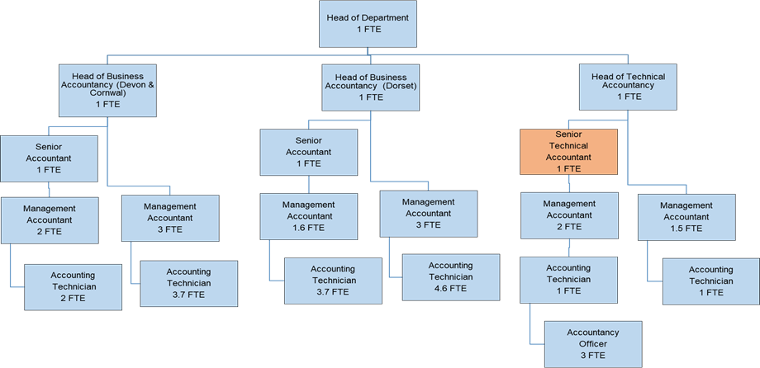

2.b Roles that work directly for this post.

Management Accountants (2 FTE posts): Perform a wide range of technical accountancy functions, including preparation of annual accounts, overseeing reconciliations including control / suspense accounts and bank accounts, audit liaison, VAT accounting and compliance reporting. These posts supervise 3 FTE Accountancy Officers, who carry out reconciliations, deal with Freedom of Information Requests, raise invoices, and provide first point of contact for general accountancy queries.

- MAIN RESPONSIBILITIES

What is the post responsible for? (INPUT) | With what results? (OUTPUT)
Deliver financial support to the business, informed by a strong understanding of technical financial requirements. | Compliance with all relevant financial regulations. Unqualified annual accounts and avoidance of potentially significant financial penalties.
Oversee the production of the annual statement of accounts, including primary statement, notes, and accounting policies; ensure systems and process used across the Department and beyond, support the provision of these accounts. | Effective and efficient production of key systems and procedures. Unqualified annual accounts
Liaison with actuaries, premises valuers, and other external bodies; obtain, challenge, and verify figures used within the accounts. | Accurate valuations used within the annual accounts; sustaining key relationships with significant bodies.
Liaison with External Audit; respond to queries promptly, updating Chief Financial Officers of significant issues. | Transparency and evidence of correctness and probity. Unqualified annual accounts
Liaison with regional and national colleagues on developments in technical accounting requirements; ensure consistency and application of best practice. | Effective networking to assure application of latest techniques/processes. and Unqualified annual accounts
Deliver regular training to Finance Department staff across technical accountancy issues | Development and maintenance of sound technical accountancy knowledge across the Finance Department; support potential for succession planning and continuity of service.
Produce regular ‘Trial balances’ during the year and full balance sheet at the half year stage; take corrective action as necessary to ensure the figures are correctly maintained | Ensure the Force is best able to meet the year end accounts process
Produce monthly Key Performance Indicators, evidence accuracy and timeliness of technical accountancy functions | Ensure key controls applied, and financial records appropriately maintained with good ‘visibility’ and accountability.
Effective management of all staff for whom the post holder is responsible; to include input into recruitment, general personnel matters, staff development and appraisals. | Ensure an efficient and effective team delivering upon objectives and fulfilling potential.
Deputise for the respective Head of Technical Accountancy as necessary; ensure representation at meetings, management of staffing issues, and preparation of papers are observed. | Ensure continuity of service at senior finance level, with accessible representation, available as necessary, delivering resilience
This list of duties is not restrictive or exhaustive and the postholder may be required to carry out duties from time to time that are either commensurate with/or lower than the grade of the post. In some posts this might include the ad-hoc provision of guidance and informal training of new colleagues. | Completion of duties to meet the needs of the Police Service.

4. CONTACTS

Five main contacts, internal or external (other than Manager), which the post-holder regularly deals with in the course of their work.

Chief Financial Officers / Treasurers to the PCCs
External / Internal Auditors
Valuers / Actuaries
Business Area leads / devolved budget holders
Regional Finance contacts
  - SPECIAL CONDITIONS/ADDITIONAL INFORMATION

List any special arrangements surrounding the job e.g., 24 hr responsibility, on-call time, and weekend work in this section.

- The Force Values together with the Police Staff Standards of Professional Behaviour are non-negotiable standards that all Dorset Police staff must abide by. Loyalty to these Values and Ethics are a requirement for membership into Dorset Police.
- This post may be located either at Dorset or Devon & Cornwall Police Headquarters, with occasional work at other locations a possibility. There will also be some capacity for home working, at employer’s discretion, with the over-riding need for role delivery; this inherently could involve physical travel/meetings.
- The financial cycle means that at certain times of the year (production of accounts, budget setting) there may be significant peaks in workload and hours.
- There are no other formal arrangements other than those which apply to police support staff generally in accordance with the emergency nature of the Police Service.

  - HEALTH & SAFETY TRAINING

Are there any specific health and safety training requirements for this role which need to be considered prior to or post appointment? [Manager should read appropriate Risk Assessments and identify training required, e.g., manual handling training, VDU assessment, Control of Substances Hazardous to Health (COSHH) etc]

You are advised to read the Force’s Health and Safety policy which will give a more in-depth description of your full Health and Safety responsibilities.

  - HEALTH MONITORING

Are there any Health Monitoring requirements specific to this post which will be considered prior to appointment/job offer?

N/A

  - VETTING

Certain designated posts require enhanced vetting in line with the Force Vetting Policy. Details of such specified below e.g., ‘this post is subject to standard recruitment vetting’ or ‘this post is subject to higher level vetting’. Vetting clearance will need to be obtained prior to appointment of a candidate.

Recruitment vetting

  - TERMS OF APPOINTMENT

The salary will be within Grade I. For full salary range refer to Dorset Police Staff pay scales.

The current core business hours will be as determined by your senior management and will be in accordance with the Force Flexi-time Policy and associated procedure, including eligibility for the flexi-time provision.

This post may be located either at Dorset or Devon & Cornwall Police Headquarters - Middlemoor or Winfrith: to be determined however the postholder will be required to travel and work from both HQs as required. There will also be some capacity for home working, at employer’s discretion, with the over-riding need for role delivery; this inherently could involve physical travel/meetings

  - PERSON SPECIFICATION

Essential Criteria

Essential Qualifications/Specific Training/Alternative relevant experience, knowledge, skills which are required for this post.
Criteria to be measured | Competencies Required
Criteria A | Educated to degree level, full membership of CCAB body (or equivalent) together with evidence of extensive post qualification experience.
Criteria B | Experience of analysing, interpreting, and presenting complex financial data, utilising appropriate software/mediums effectively as appropriate; demonstrable evidence of gathering facts and ideas to support presentations and report production. Use of computer software, including financial systems and spreadsheets, at an advanced level in the support of interrogation and analysis of data or to support conveyance of reports.
Criteria C | Sound interpersonal and communication skills; demonstrable ability to influence others in a plausible and convincing manner to audiences at any level across the organisation.
Criteria D | Proven leadership and management experience; including directing activity, appraisal, and performance monitoring.
Criteria E | Problem solver with significant experience in identifying and resolving matters; evidenced ability to proactively seek out potential challenges and credible solutions. Demonstrable commitment/record of ongoing service development.
Criteria F | Demonstrable commitment to continuous improvement, well-motivated and keenness to learn/challenge/adapt with inquisitive approach; evidenced ability to adapt to a changing environment and support departmental and organisational change. Interest in best practice and the development of technologies and their application in a financial setting.

Desirable Criteria (if applicable)

Desirable Qualifications/Specific Training/Alternative relevant experience, knowledge, skills which are required for this post.
Criteria to be measured | Competencies Required
Criteria G | Experience of public sector accounting, including an understanding of the ‘political context’ for budget setting and control

